As shown in the picture below, there is an "empty object" which is named NpcCounter. Its npc gameobjects, which are child objects, hold a script that is named npccontroller on them. Here , we can set the speed of backward movement speed on this . If we want the speed not to change after hitting obstacles, we need to keep the variable speed after hit obstacle the same as backward speed. The health here works in conjunction with the damage variable on the weapon. We can make it die in more than one bullet by increasing the health variable or decreasing bullet damage.

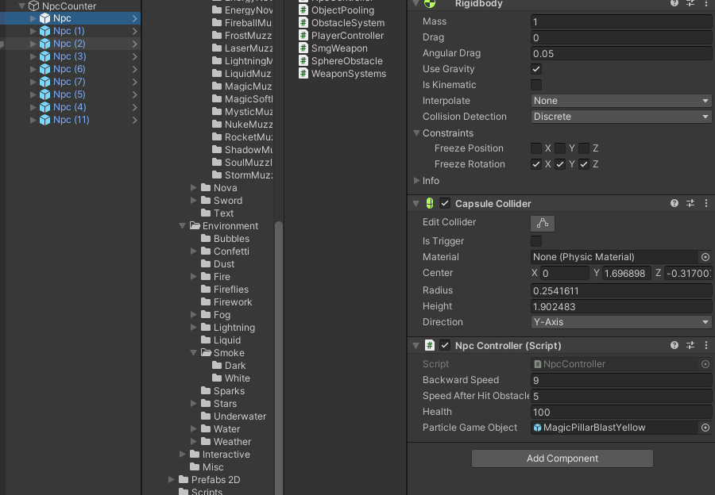

There is a script of their own for the children of the obstacles prefab. When we hit obstacles , just our speed slows down. It holds the particle variable that will work after being destroyed. But it was left open to improvement.

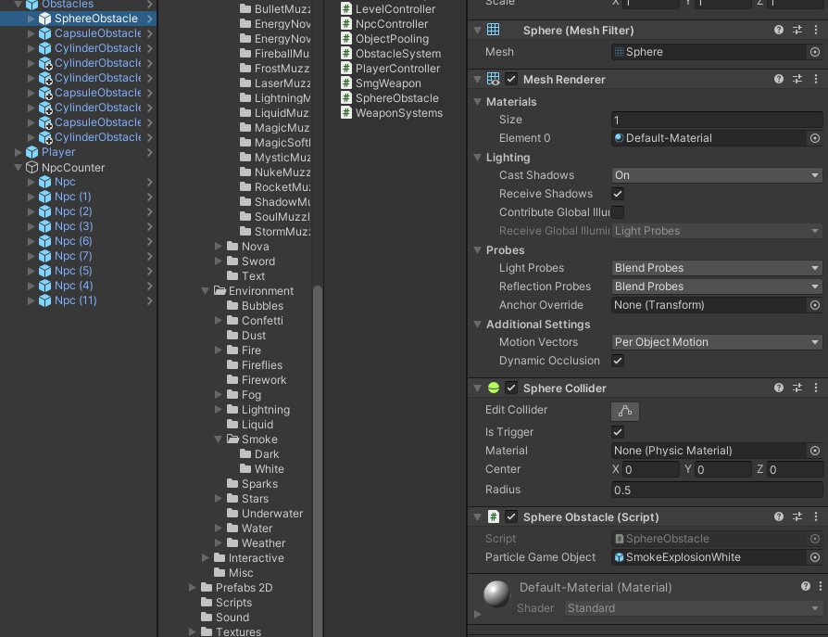

Unlike the npccontroller script, the playercontroller script on the player contains a horizontal speed variable. This variable determines the speed of movement to the right and left. There is no health variable in the player since it dies in one shot.

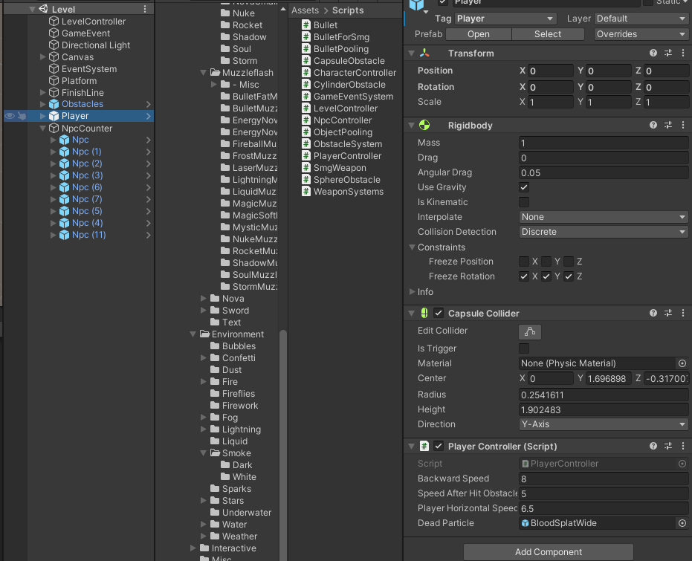

We can make adjustments on the weapon with the smgweapon script which is on the weapon prefab. FireRate variable returns a float value of 100 / fireRate. Here the value 1000 was entered 100/1000 = 0.1f , that is, it will shoot a bullet every 0.1 seconds. If we want it to fire faster, we must increase the value. Damage variable allows us to determine after how many bullets are shooted to the npc will die. Bulletpool, which is a weapon child, is the gameobject where our bullets are kept. Thanks to this, we do not create and destroy the bullets every time, instead we take them from the pool and send them back to the pool when the job is done.

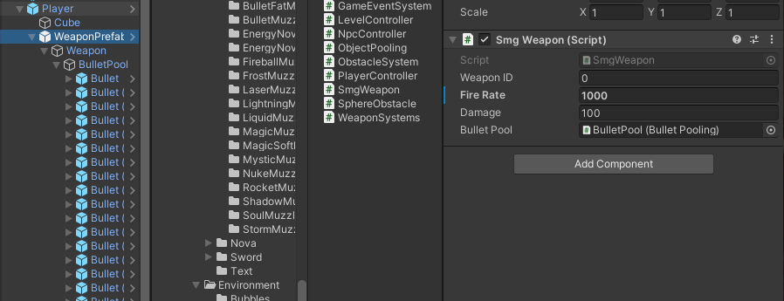

There is a script which is named bulletforsmg on bullets and the damage variable in this script is taken from the weapon. The picture here is shown for explanation purposes. In the program, this variable is not SerializeField. We can adjust the speed of the bullet with the speed variable.

